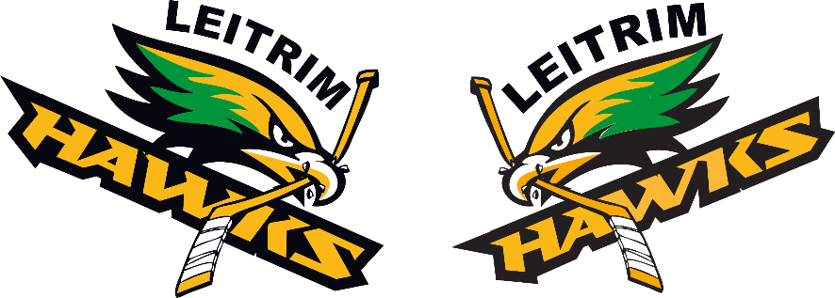 | Leitrim Minor Hockey Association  2025/26  Competitive B Coaching Application Form

Submission Process:

- Application Deadline: May 1, 2025
- Please open this document with word processing software and enter data. Send the completed form to Competitive@LeitrimHockey.ca with your supporting documents.
- If you complete the form by hand, please print clearly. Please scan the completed form and email to Competitive@LeitrimHockey.ca with supporting documents.
- Interviews are expected to be conducted in mid to late May.
- Candidates will be contacted by the selection committee with their interview times.
- Coaching positions will be offered conditionally on successful police criminal record check being carried out.
- The successful candidates will be expected to hand in a list of their team staff to the committee for approval once tryouts are over.
- Please note Merged teams can happen but note applications will still be considered and applicants will be contacted

Supporting Documents:

The following supporting documents are to be submitted together with this form, or as attachments to your e-mail message:

- Additional details on your hockey experience
- Your hockey philosophy

Minimum Requirements for all Applicants:

- All applicants must have previous coaching experience.
- All applicants must have, or must obtain by specified deadlines, the required training/certification for the Division they coach. Please see below for current requirements.

 | U10/U11 Coaches | U12-U18 Coaches
Head Coach | Coach 2, Respect in Sport, GIOT | Development 1, Respect in Sport, GIOT
Assistant Coaches | Coach 2, Respect in Sport, GIOT | Development 1, Respect in Sport. GIOT

Please see these links for more information: HEO Certification Requirements Hockey Clinic Registration

Send the completed 2025-2026 Competitive B – Coaching Application Form
with all supporting documents to Competitive@LeitrimHockey.ca by May 1, 2025
Leitrim Minor Hockey Association

2025-26 Competitive Rep B - Coaching Application Form

Applicant’s Name:
Email Address 1: |  | Email Address 2:
Home Address: |  | Postal Code:
City/Town: |  | Home Phone:
Work Phone: |  | Cell Phone:
Employer: |  | Job Title:

- I am interested in a Head Coach position for :
 | U10 | U11 | U12 | U13 | U14 | U15 | U16 | U18

- Are you also applying this season as a Head Coach with the Gloucester Rangers or any other Association above Rep B?
Yes ______ No _______.

- Previous coaching experience. (Add lines as required please.)
Year | Organization | Age  Category | Level  (i.e. House, Rep B, A, AA, AAA) | Head Coach?  (Yes or No)
- Please list all Hockey Coaching Certification that you have completed:

________________________________________________________________________________________________________________
- References familiar with your hockey involvement.

Name:
Phone:
E-mail:
Details:
Name:
Phone:
E-mail:
Details:
Name:
Phone:
E-mail:
Details:

